Using Flood Risk and Property Data to Assess Public Asset Vulnerability in Pinellas County, Florida
Donald Melone, Jr., May 10, 2026

Abstract
The coastal communities of Florida are increasingly susceptible to flooding due to urban expansion, rising sea levels, and an escalation in the frequency and severity of natural disasters. Pinellas County, Florida, is particularly vulnerable owing to its concentrated development, predominantly low-lying terrain, and residents' reliance on critical infrastructure for transportation, recreation, and economic activities. This study employed geographic information systems (GIS) combined with spatial analytical techniques to evaluate the vulnerability of public assets and developed parcels within flood hazard zones designated by the Federal Emergency Management Agency (FEMA) in Pinellas County. FEMA flood hazard zone data were integrated with parcel-specific property information, public park boundaries, emergency shelter locations, and additional publicly accessible GIS datasets obtained from Pinellas County Open Data. Analytical procedures, including “Spatial Join” and “Intersection,” were performed in ArcGIS Pro on the compiled datasets, enabling the identification of parcels within flood hazard zones, the classification of parcels by FEMA hazard categories, and the estimation of the total property value at risk of flooding.
Following the analyses, this study identified 166,970 unique parcels located within FEMA flood hazard zones, representing approximately 38.24% of all parcels in Pinellas County. Of these parcels, 854 were identified as county-owned properties. The summarized property value in the "high” and “moderate” categories within flood hazard areas exceeded $124 billion. Many of the identified unique parcels are concentrated in AE and VE FEMA flood hazard zones. These results underscore that a significant portion of Pinellas County’s built environment and public infrastructure is exposed to frequent flood risk. The final analysis affirms the value of GIS-based spatial analysis as a decision-support tool for asset management, sustainability, resilience planning, and ultimately, for prioritizing infrastructure investments in disaster-prone coastal regions.

Introduction and Literature Review
Natural disasters have profound social, economic, and environmental impacts across the United States, particularly in rapidly expanding coastal regions that are susceptible to hurricanes, flooding, and storm surges. The incidence of disasters incurring damages exceeding billions of dollars has risen markedly, thereby exerting substantial pressure on local authorities tasked with safeguarding public infrastructure, emergency response capabilities, and recreational amenities accessible to citizens. Coastal communities in Florida face heightened vulnerability owing to extensive commercial and residential development in low-lying zones.
The 2024 Atlantic hurricane season revealed numerous shortcomings within communities across the southeastern United States, particularly in Florida, following Hurricane Milton's landfall south of Tampa Bay. Both Hurricanes Helene and Milton inflicted considerable damage throughout Florida and neighboring states, disrupting residents' daily routines, impairing public and private infrastructure, and imposing unforeseen financial burdens on municipal budgets. Many municipalities, already experiencing economic constraints, encountered additional obstacles in their recovery efforts. The repercussions of Hurricanes Helene and Milton prompted discussions—both internally and among municipal authorities—regarding outdated infrastructure and the challenges arising from diverse local economies, all of which underscore the necessity for effective planning and asset management strategies.
Pinellas County, Florida, exemplifies the vulnerability of public assets. This densely urbanized coastal region contains a substantial concentration of infrastructure, including both public and private facilities located in flood-prone areas. Its territory incorporates numerous public amenities, transportation systems, recreational spaces, and other municipal assets that serve residents' needs and support a tourism-oriented economy. Increasing population growth and coastal development exacerbate flood risk exposure while simultaneously augmenting the responsibilities of local authorities to sustain infrastructure resilience.
Geographic Information Systems (GIS) and spatial analysis methodologies are indispensable tools utilized for hazard assessment, infrastructure development, and disaster response. Spatial analysis enables professionals, researchers, and urban planners to delineate exposure patterns and evaluate the sustainability and vulnerability of infrastructure, thereby facilitating data-informed decision-making. The integration of FEMA flood hazard data with local parcel and infrastructure datasets provides an effective means to quantify flood exposure and analyze risk distribution within developed areas and public assets. This study employs GIS-based spatial analysis to assess flood exposure for developed parcels and public spaces in Pinellas County. The primary objective is to demonstrate how spatial analysis can help local governments identify vulnerable infrastructure, prioritize investments, and enhance resilience planning.

Research Question:
How can spatial analysis of flood risk data help identify vulnerable public assets in Pinellas County, Florida?

Research Objectives:
Objective 1: Identify assets located within FEMA-designated flood hazard zones.
Objective 2: Use GIS spatial analysis to classify levels of flood exposure.
Objective 3: Assess the potential impact of flood exposure on future asset management and resilience planning decisions within Pinellas County.

Increasing Disaster Risk and Coastal Vulnerability
The escalating impact of natural hazards on populations in coastal regions is primarily attributable to urban expansion, environmental changes, and policies that heighten the vulnerability of infrastructure and communities. Numerous scholars assert that disasters are frequently exacerbated by human decisions concerning land use, planning, and infrastructure investments, rather than solely by inherent natural factors. Kelman (2020) emphasized that many disasters are characterized as “disasters by choice,” recognizing that communities continue to develop in hazard-prone areas despite widespread awareness of environmental risks. Similarly, Montz et al. (2017) observed that increases in population and economic activities within coastal zones have amplified global vulnerability to disasters.
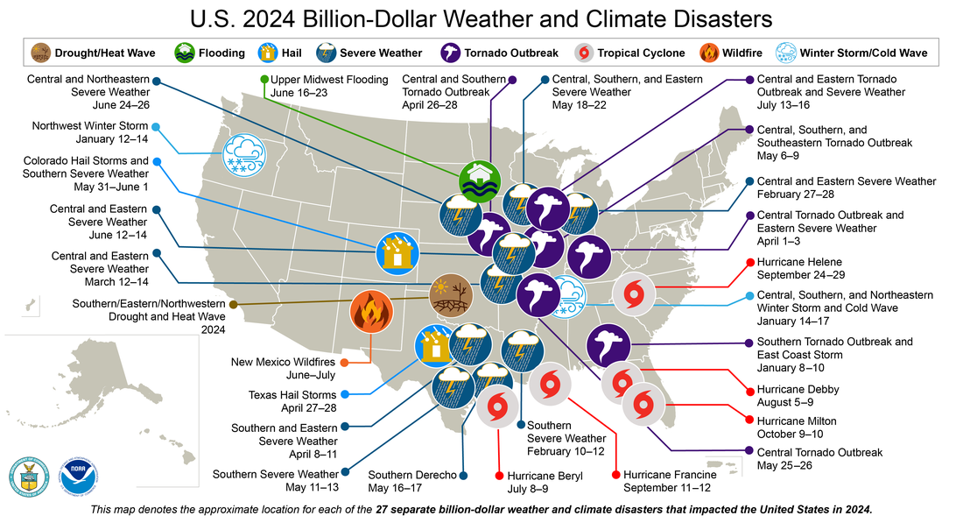
Figure 1: NOAA map showcasing documented disasters around the United States by NCEI.
Florida is among the most hazard-prone states within the United States, primarily due to its extensive coastline, low elevation, and recurrent hurricanes. Keller and DeVecchio (2019) emphasize that hurricanes pose threats such as wind damage, flooding, storm surges, and erosion. These hazards frequently trigger successive effects that disrupt transportation, utilities, public spaces, and local economies. Data from NOAA's Billion-Dollar Disaster map (Figure 1) shows the economic impact of hurricanes and severe weather events throughout 2024.
Economic vulnerability represents a considerable concern for coastal communities. Clayton et al. (2021) argued that climate-related flood risks increasingly influence real estate markets and long-term property valuations. Gallagher and Hartley (2017) noted that natural disasters have enduring financial repercussions on households and communities, particularly when recovery expenditures exceed available resources. Howell and Elliott (2019) further demonstrated that disasters can intensify wealth inequality through inequitable recovery mechanisms and unequal access to resources. Beyond immediate economic damage, communities encounter significant social repercussions following disasters. Peacock et al. (2018) analyzed issues related to temporary housing and recovery initiatives, while Petterson et al. (2006) detailed extensive social and economic disruptions caused by Hurricane Katrina. Empirical evidence consistently indicates that infrastructure failures and delayed recovery efforts contribute to ongoing stress among affected populations.

GIS and Spatial Analysis for Hazard Assessment
Geographic Information Systems (GIS) and remote sensing technologies are essential tools in modern disaster response, hazard assessment, and asset management. Spatial analysis enables integrating various datasets, visualizing hazard exposure, and assessing infrastructure vulnerability across regions. FEMA flood hazard maps are regularly used to pinpoint flood-prone areas. When combined with local data, these offer numerous opportunities for in-depth spatial analysis.
Remote sensing and unoccupied aerial vehicle (UAV) technologies have gained increasing significance in post-disaster assessments and infrastructure monitoring. Adams and Friedland (2011) emphasized the expanding application of UAV imagery in disaster management, whereas Daud et al. (2022) recognized drone technologies as cost-effective instruments for damage assessment and emergency response. Gong (2014) illustrated the utilization of remote sensing techniques to accelerate post-hurricane reconstruction evaluations and infrastructure recovery planning.
Spatial analysis techniques are widely used to identify vulnerable infrastructure and support resilience planning. Liu and McNeil (2020) contended that resilience concepts should be seamlessly integrated into risk-based asset management strategies. Geographic Information System (GIS)-based hazard analysis enables planners to assess the relationships between infrastructure systems and environmental hazards, thereby facilitating informed investment decisions. Flood exposure analysis commonly utilizes overlay methods, such as “Spatial Join” and “Intersection,” to identify assets situated within peril zones. These techniques assist researchers in quantifying exposure, evaluating risk levels, and projecting the economic consequences of flooding. As local governments progressively adopt GIS technologies, spatial analysis has become an integral instrument for infrastructure and emergency response planning.

Infrastructure Resilience and Asset Management
Asset management has advanced considerably over recent decades, with governments and organizations increasingly recognizing the importance of lifecycle planning, risk evaluation, and infrastructure resilience. Modern frameworks focus on understanding infrastructure conditions, failure likelihoods, and business risk exposure. Allen et al. (2025) emphasized the importance of including resilience and climate adaptation in transportation asset management. Similarly, Dix et al. (2023) pointed out that transportation agencies need to incorporate climate change and extreme weather events into their infrastructure planning. These academic insights indicate that archaic infrastructure management approaches are no longer sufficient in areas heavily affected by natural hazards.
Furthermore, annual budget cycles impose various challenges on municipalities, necessitating decision-makers to balance resilience and sustainability with economic considerations. Consequently, there is heightened emphasis on asset management. Warren (2010) asserted that public-sector asset managers bear primary responsibility for disaster preparedness and continuity planning. Effective infrastructure management requires precise inventory documentation, strategic long-term planning, and prioritization based on vulnerability assessments. Additionally, Kaplan and Mikes (2016) emphasized the importance of risk management frameworks designed to identify and mitigate emerging threats.
Local governments often encounter fiscal constraints that impede infrastructure maintenance and disaster response endeavors. Various economic factors, including the repercussions of multiple downturns over the last twenty years, continue to obstruct progress. Ongoing budget restrictions, rising operational expenses, and deferred maintenance activities exacerbate infrastructure vulnerabilities. Consequently, municipalities are increasingly adopting technological solutions, such as Geographic Information Systems (GIS), remote sensing, and automated data collection systems, to enhance efficiency and support strategic planning.

Post-Disaster Recovery and Community Impacts
Research on post-disaster recovery demonstrates that infrastructure is integral to establishing community resilience. Transportation networks, utilities, and recreational facilities facilitate both emergency response and long-term economic revitalization. Reinforcing existing systems is essential, as many serve as safe havens for affected communities during natural disasters. Studies conducted in Puerto Rico and across various Caribbean communities following major hurricanes highlight numerous challenges in recovery planning and infrastructure rehabilitation. Delilah Roque et al. (2020) emphasized the importance of social capital in disaster recovery efforts. Conversely, Medina et al. (2019) highlighted the critical need for collecting vulnerability data through post-disaster surveys and assessments.
Infrastructure failures hinder economic stability in regions reliant on tourism and impede public recovery efforts. Mair et al. (2016) observed that tourist destinations frequently endure prolonged periods of economic disruption following catastrophic events. Safapour et al. (2022) identified several critical factors for successful post-hurricane reconstruction, including prioritizing infrastructure, effective coordination, and optimal resource allocation. Economic conditions significantly influence tourists' attraction to coastal areas; for instance, Spring Break exemplifies tourism activities that are susceptible to the impacts of natural disasters. When a disaster affects a tourist destination before a peak season, restrictions may be imposed on potential visitors. Small communities dependent on tourism revenue may find it increasingly challenging to sustain their recovery trajectory once tourism income declines.
The literature reviewed in this research emphasizes the importance of integrating GIS-based hazard analysis with resilience and sustainability initiatives to develop targeted asset management strategies for coastal communities vulnerable to frequent and costly natural disasters. However, there is a notable scarcity of studies that specifically examine county-level public asset exposure through parcel-scale spatial analysis within Pinellas County, Florida. This research contributes to the existing body of knowledge by integrating flood hazard analysis with public asset management considerations in a highly urbanized coastal environment.

Data and Methods

Study Area
The designated study region for this project encompasses Pinellas County, Florida. Situated along the middle of Florida's Gulf Coast, Pinellas is part of the Tampa Bay metropolitan area. The county ranks among the most densely populated counties in Florida, featuring a diverse array of residential, commercial, natural, and public recreational areas. It is bordered by the Gulf of Mexico to the west and Tampa Bay to the east.
This distinctive geographical configuration—a peninsula on a peninsula—renders the area particularly vulnerable to storm surge and coastal flooding. The region’s consistently low elevations, lack of vertical variety, and extensive coastal development contribute to elevated flood vulnerability. Many residential communities within the county limits are located inside FEMA flood hazard areas, which coincide with evacuation zones. In addition to permanent residents, the county supports a substantial tourism economy that depends heavily on functioning infrastructure systems, transportation access, and recreational amenities.

Data Sources
This research utilized publicly accessible Geographic Information System (GIS) datasets obtained from federal and municipal government agencies. FEMA Flood Hazard Areas were sourced from the FEMA Flood Map Service Center and used to delineate flood hazard zones within the study region. Parcel-specific property data, including assessed land and total property values, was obtained from the Pinellas County Open Data portal.
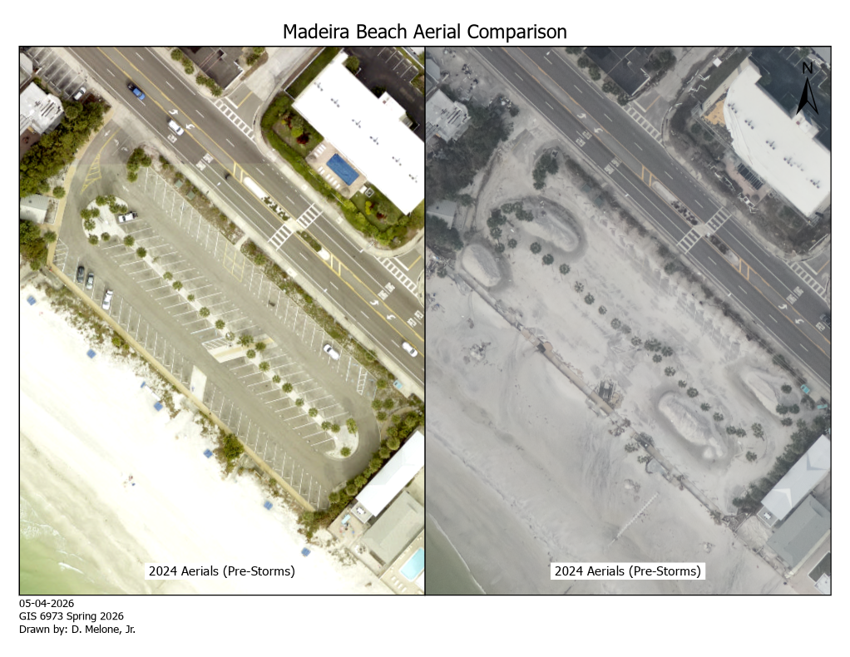
Figure 2 Madeira Beach Aerial Comparison Pre and Post Hurricanes
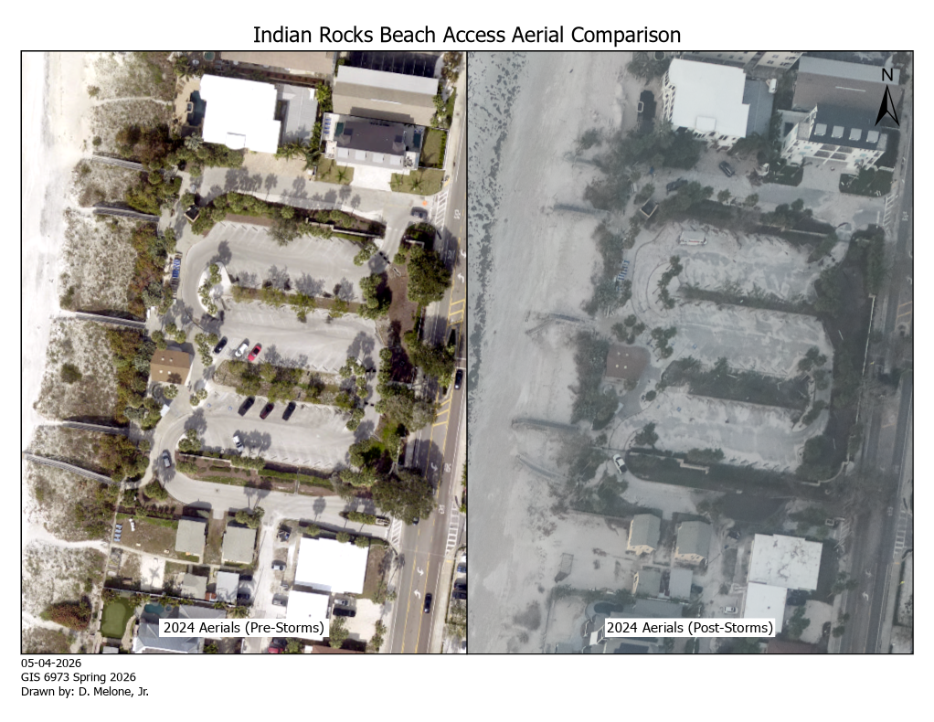
Figure 3 Indian Rocks Beach Access Aerial Comparison Pre and Post Hurricanes
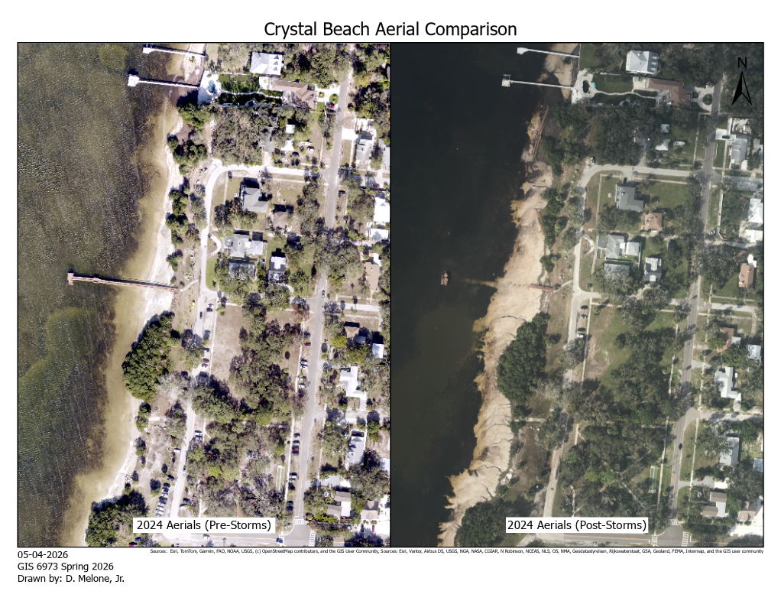
Figure 4 Crystal Beach Aerial Comparison Pre and Post Hurricanes
The supplementary datasets employed for analysis and map creation encompass county land boundary geometries, park boundary layers, emergency shelter locations, evacuation routes, land use data, zoning information, and aerial imagery captured immediately prior to the 2024 hurricane season. Furthermore, ArcGIS Online imagery services and NOAA resources provided additional visual references, thereby supporting the development of various maps. Figures 2 through 4 illustrate a comparison of aerial imagery taken before the 2024 hurricane season on the left, with imagery on the right depicting conditions following Hurricane Milton at the specified locations indicated in the map title and image caption.

GIS Processing and Spatial Analysis
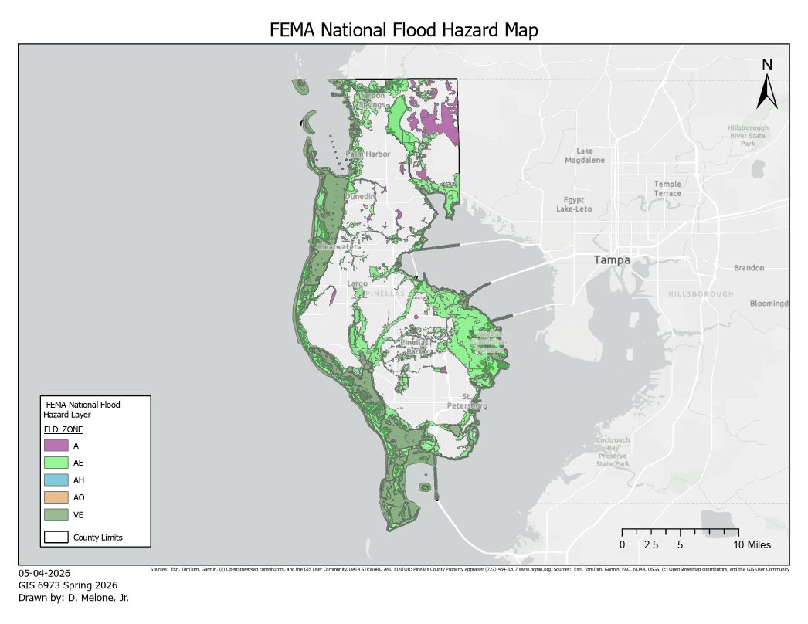
Figure 5 FEMA National Flood Hazard Map - Pinellas County
All spatial analysis procedures were performed in ArcGIS Pro 3.6.4. Datasets imported for this study were projected, as needed, to ensure consistency, using the Florida State Plane West coordinate system. Before conducting overlay operations, the "Repair Geometry” tool was applied to several layers to ensure compatibility. The live data required for spatial analysis was exported as a layer into the project geodatabase stored on a local drive.
Flood hazard data were prepared by excluding FEMA flood zones classified as “X” and “Open Water” to focus analysis on regions with moderate to high flood risk. Subsequently, the employment of "Spatial Join” and “Intersect” operations was executed on the parcel datasets and FEMA flood hazard polygons to determine parcels situated within flood hazard zones. Further analyses were conducted to identify county-owned parcels intersecting with flood hazard areas. Additionally, spatial analysis procedures included intersecting park boundaries with flood hazard zones to pinpoint vulnerable recreational infrastructure. The initial map data output, as depicted in Figure 5 above, illustrates the filtered FEMA hazard zone data excluding “X” and “Open Water”.
A bespoke risk classification field was incorporated into the combined FEMA and County data attribute table. Data for this new field were generated utilizing the ArcGIS “Calculate Field” functionality to categorize flood exposure levels based on FEMA flood zone designations. VE zones were identified as representing a “high” risk, given that this zone indicates the highest potential for coastal flooding and wave action during a severe hurricane event, as delineated by FEMA. Zones “AE” and “A” were designated as “moderate” risk. As previously noted, Zones “X” and “Open Water” were excluded from the primary analysis in this classification. Statistical summaries were computed to quantify the number of unique parcels located within FEMA flood hazard areas, the percentage of total parcels within these hazard areas, and the estimated property value at risk. Descriptive statistics were further organized according to flood zone classification.
The chosen methodologies explicitly align with this study’s research aims. The “Intersection” geoprocessing analysis fulfills Objective 1 by pinpointing public assets located within flood hazard zones. The risk classification assignment in the combined attribute table corresponds to Objective 2 through the categorization of exposure levels. Lastly, statistical summaries and spatial pattern analysis underpin Objective 3 by assessing the implications of flood exposure concerning resilience planning and public asset management.

Results
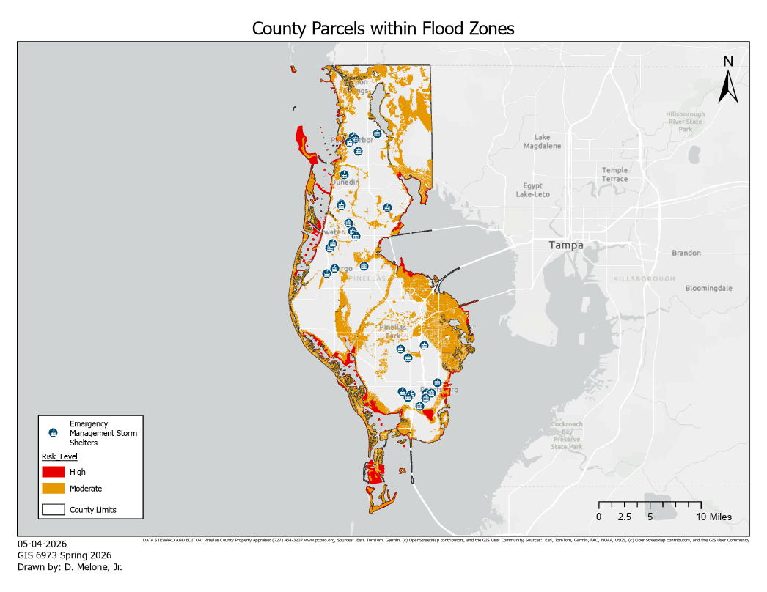
Figure 6 County Parcels map - with FEMA Flood Zones analyzed as High or Moderate risk

Parcel Exposure to Flood Hazard Zones
The spatial analysis identified 166,970 parcels situated within FEMA-designated flood hazard zones within the jurisdiction of Pinellas County. These distinctive parcels (as enumerated in Table 1 below) constitute approximately 38.24% of all unique parcels within Pinellas County. The vast majority of at-risk parcels were in private ownership, while 854 parcels owned by the county were situated within flood hazard areas. The spatial analysis corroborates that a considerable portion of developed land within Pinellas County is susceptible to moderate to high flood risk. Many parcels, as depicted in Figure 6 above, are concentrated in coastal municipalities and in low-lying, developed corridors adjacent to Tampa Bay and the Gulf of Mexico. Figure 6 above presents these “high” and “moderate” risk unique parcels, along with their spatial relationship to emergency storm shelters—assets potentially vital for life safety during natural calamities.
Table 1 Unique parcel count in FEMA Flood Hazard Zones
Characteristic | Count | Percentage
Parcels in Flood Zones | 166,970 | 38.24%
Private parcels | 166,116 | 38.04%
County-owned parcels | 854 | 0.19%

Property Value at Risk
Table 2 Total property value at risk in FEMA Flood Hazard Zones
Flood Zone | Count | Value
A | 8,694 | $2,369,591,050.00
AE | 235,360 | $102,195,849,440.00
AH | 66 | $10,454,900.00
AO | 381 | $413,859,709.00
VE | 31,091 | $19,196,889,087.00

The total assessed property value intersecting the analyzed flood hazard zones exceeded $124 billion, as illustrated in Table 2 above. The majority of this value was concentrated within AE and VE flood zones. The AE flood zone encompassed the highest concentration of exposed parcels and property value, amounting to over $102 billion in assessed value. VE zones, which are associated with coastal high-hazard areas and wave action, contained more than $19 billion in assessed property value. The distribution of property value within flood hazard zones indicates that flood exposure extends beyond isolated coastal properties and impacts a significant portion of the county’s developed economic infrastructure.

Public Asset Exposure
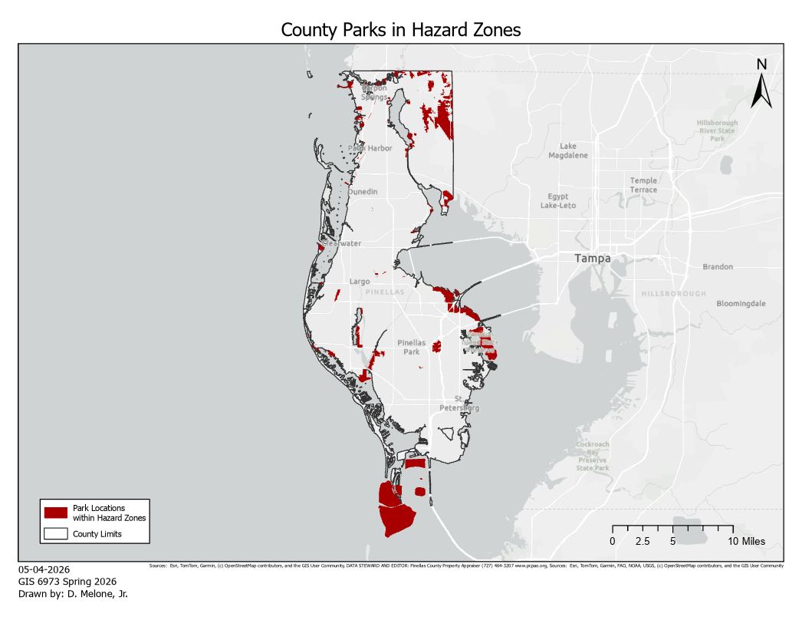
Figure 6 County Parks intersecting FEMA moderate to high hazard zones
Further spatial analysis revealed that numerous county-owned parcels include park facilities located within flood hazard zones. As depicted in Figure 6, several public parks and recreational amenities intersect with coastal flood zones, indicating vulnerability to storm surge and recurring storm damage. As illustrated in Figure 5, emergency management infrastructure, including shelters and evacuation corridors, also varies in proximity to flood-prone areas. The clustering of public assets in these vulnerable locations underscores the operational challenges local governments face in maintaining service continuity in the aftermath of disasters.

Spatial Vulnerability Patterns
One outcome of the analysis indicates that flood hazard patterns generally corresponded with highly developed coastal locations and densely urbanized corridors throughout Pinellas County. Coastal municipalities and barrier island communities contributed to particularly high concentrations of at-risk parcels and, by default, infrastructure. The spatial vulnerability results also indicate that flood risk and development pressure overlap significantly throughout the study area. Despite widespread awareness of flood hazards, substantial investment in residential, recreational, and public infrastructure continues in disaster-vulnerable areas.

Discussion
Kelman (2020) asserted that numerous disasters are affected by planning decisions and land-use policies that increase community vulnerability to hazards. The findings of this study indicate a substantial concentration of development within AE and VE flood zones throughout Pinellas County, mirroring broader national trends in coastal urbanization and hazard exposure. Additionally, the data demonstrates a considerable overlap between coastal development and flood hazard zones. Over one-third of all unique parcels are situated within FEMA-designated flood hazard zones.
The clustering of high-risk parcels indicates a concentration of assets vulnerable to hurricane-induced flooding and storm surge events. Throughout this research, the analysis corroborates extant scholarly literature, demonstrating that development patterns consistently exacerbate disaster vulnerability in coastal regions. The significant property values, as outlined in Table 2, within flood hazard zones further underscore the economic consequences of recurrent disasters for local authorities and residents. As climate-related hazards become more frequent and intense, expenditures related to infrastructure repair, insurance, and recovery are expected to increase.
Local governments, entrusted with the responsible management of public infrastructure, may encounter increasing financial pressures as recurring storm damage accelerates the deterioration of infrastructure. Consequently, as budgets become more limited and the need for personnel efficiencies varies in accordance with economic conditions, public pressure and expectations intensify, thereby affecting the decision-making capabilities of municipal leadership. Public asset exposure constitutes a particularly significant finding of this research. County-owned parcels, parks, shelters, and infrastructure systems situated within flood-prone zones are vulnerable to repeated operational disruptions and maintenance challenges following major storms.
Damage to public facilities can impede recovery efforts, disrupt essential services, and diminish public confidence in governmental response capabilities. The study also underscores the significance of GIS-based spatial analysis in resilience planning and infrastructure management. Spatial analysis tools enable planners and asset management teams to identify vulnerable assets, prioritize blue- or gray-sky maintenance and mitigation initiatives, and facilitate evidence-based investment decisions. GIS technologies, such as ArcGIS Pro, further enhance interdisciplinary communication by providing visual representations of hazard exposure and infrastructure vulnerability. Asset management strategies are increasingly oriented towards resilience and lifecycle planning rather than reactive maintenance. The integration of flood exposure analysis into infrastructure planning allows local authorities to optimize resource allocation and pinpoint assets requiring enhanced protection or adaptation measures.
Several limitations must be acknowledged. Firstly, FEMA flood hazard maps depict generalized regulatory flood zones and may not encompass all local flooding conditions or account for future sea-level rise impacts. Because of this generalization, it is incumbent upon local governments to document and analyze their first-hand data in comparison to the national FEMA hazard data. Secondly, parcel values are subject to fluctuation over time and may not accurately reflect actual replacement costs following disasters. Lastly, this study primarily focuses on flood exposure rather than direct damage estimation or predictive storm-surge modeling. Future research could enhance this analysis by integrating social vulnerability indicators, infrastructure condition assessments, and time-series analyses of storm impacts. Additionally, further studies examining work-order data, maintenance costs, and post-disaster recovery expenditures could significantly contribute to a more comprehensive understanding of long-term infrastructure vulnerability within coastal communities.

Conclusion
This study employed GIS-based spatial analysis to assess flood exposure among parcels and public assets within Pinellas County, Florida. By integrating FEMA flood hazard data with local parcel datasets, the research identified significant concentrations of developed properties and public locations situated within flood-prone areas. The analysis revealed that approximately 38% of parcels in Pinellas County are situated within FEMA-designated flood hazard zones, representing an assessed property value exceeding $124 billion. Public infrastructure assets, including parks and county-owned properties, were also observed to intersect with vulnerable coastal flood zones and constitute approximately 0.2% of the unique parcels within flood hazard zones.
The findings underscore the escalating importance of sustainable and resilient asset management spearheaded by local municipalities operating within coastal communities that are repeatedly impacted by hurricanes and related hazards. Geospatial technologies and spatial analysis methodologies offer essential tools for local governments to identify vulnerable infrastructure, prioritize investments, and enhance emergency preparedness initiatives. Ultimately, every dollar allocated to these assets and management programs constitutes taxpayer funds. As populations along coastlines continue to grow and climate-related threats intensify, local authorities are expected to encounter increased difficulties in maintaining infrastructure, recovering from disasters, and preserving fiscal stability. The integration of spatial analysis into public asset management promotes superior planning decisions and bolsters community resilience over the long term.
Future research should persist in investigating the interrelations among infrastructure vulnerability, social impacts, and disaster recovery within coastal regions. The enhanced integration of social vulnerability data, predictive flood modeling, and infrastructure condition assessments would markedly advance understanding of risk exposure and resilience planning prerequisites in Pinellas County as well as comparable coastal communities. Several local governments have prioritized essential initiatives to rectify data deficiencies in the nearly two years following the historic 2024 hurricane season, with the aim that, when—not if—the next natural disaster occurs, local authorities will possess the necessary data to facilitate the prompt and effective management of damaged public assets.

References:
2024: An active year of U.S. billion-dollar weather and climate disasters | NOAA Climate.gov [WWW Document], 2025. URL https://www.climate.gov/news-features/blogs/beyond-data/2024-active-year-us-billion-dollar-weather-and-climate-disasters (accessed 10.21.25).
Adams, S.M., Friedland, C.J., (2011). A survey of unmanned aerial vehicle (UAV) usage for imagery collection in disaster research and management, in: 9th International Workshop on Remote Sensing for Disaster Response. pp. 1–8.
Alexander, D., 2018. Natural disasters. Routledge.
Allen, E., Costello, S.B., Henning, T.F.P., Chamorro, A., Echaveguren, T., 2025. Integration of resilience and risk to natural hazards into transportation asset management of road networks: a systematic review. Structure and Infrastructure Engineering 21, 755–773. https://doi.org/10.1080/15732479.2023.2238281
Argyroudis, S.A., Mitoulis, S.A., 2021. Vulnerability of bridges to individual and multiple hazards-floods and earthquakes. Reliability engineering & system safety 210, 107564.
Cameron, L., Shah, M., 2015. Risk-taking behavior in the wake of natural disasters. Journal of human resources 50, 484–515.
Chandrasekhar, D., García, I., Khajehei, S., 2022. Recovery Capacity of Small Nonprofits in Post-2017 Hurricane Puerto Rico. Journal of the American Planning Association 88, 206–219. https://doi.org/10.1080/01944363.2021.1938637
Chaudhary, M.T., Piracha, A., 2021. Natural disasters—origins, impacts, management. Encyclopedia 1, 1101–1131.
Clayton, J., Devaney, S., Sayce, S., Van de Wetering, J., 2021. Climate risk and real estate prices: what do we know? Journal of Portfolio Management 47.
Daud, S.M.S.M., Yusof, M.Y.P.M., Heo, C.C., Khoo, L.S., Singh, M.K.C., Mahmood, M.S., Nawawi, H., 2022. Applications of drone in disaster management: A scoping review. Science & Justice 62, 30–42.
Delilah Roque, A., Pijawka, D., Wutich, A., 2020. The Role of Social Capital in Resiliency: Disaster Recovery in Puerto Rico. Risk Hazard & Crisis Pub Pol 11, 204–235. https://doi.org/10.1002/rhc3.12187
Dix, B., Wagner, H., Vargo, A., Proctor, G., Varma, S., Filosa, G., 2023. Addressing Resilience to Climate Change & Extreme Weather in Transportation Asset Management. United States. Department of Transportation. Federal Highway Administration.
Gallagher, J., Hartley, D., 2017. Household finance after a natural disaster: The case of Hurricane Katrina. American Economic Journal: Economic Policy 9, 199–228.
Gong, J., 2014. A Remote Sensing-based Approach for Assessing and Visualizing Post-Sandy Damage and Resiliency Rebuilding Needs, in: Construction Research Congress 2014. Presented at the Construction Research Congress 2014, American Society of Civil Engineers, Atlanta, Georgia, pp. 1259–1268. https://doi.org/10.1061/9780784413517.129
Griffith, C., Mjelde, J.W., DinHobl, M., n.d. Enhancing Disaster Preparedness: Assessing Public Willingness to Pay for Improved Transit District Services for Evacuation and Post-Hurricane Support. Available at SSRN 4953231.
Hallegatte, S., Vogt-Schilb, A., Bangalore, M., Rozenberg, J., 2016. Unbreakable: building the resilience of the poor in the face of natural disasters. World Bank Publications.
Harrison, C.G., Williams, P.R., 2016. A systems approach to natural disaster resilience. Simulation Modelling Practice and Theory 65, 11–31.
Howell, J., Elliott, J.R., 2019. Damages done: The longitudinal impacts of natural hazards on wealth inequality in the United States. Social problems 66, 448–467.
Huang, S.-K., Lindell, M.K., Prater, C.S., 2016. Who Leaves and Who Stays? A Review and Statistical Meta-Analysis of Hurricane Evacuation Studies. Environment and Behavior 48, 991–1029. https://doi.org/10.1177/0013916515578485
Hubbard, D.W., 2020. The failure of risk management: Why it’s broken and how to fix it. John Wiley & Sons.
Josephson, A., Schrank, H., Marshall, M., 2017. Assessing preparedness of small businesses for hurricane disasters: Analysis of pre-disaster owner, business and location characteristics. International journal of disaster risk reduction 23, 25–35.
Kaplan, R.S., Mikes, A., 2016. Risk Management—the Revealing Hand. J Applied Corp Finance 28, 8–18. https://doi.org/10.1111/jacf.12155
Keller, E.A., DeVecchio, D.E., 2019. Natural hazards: earth’s processes as hazards, disasters, and catastrophes. Routledge.
Kelman, I., 2020. Disaster by choice: How our actions turn natural hazards into catastrophes. Oxford University Press.
Liu, Y., McNeil, S., 2020. Using Resilience in Risk-Based Asset Management Plans. Transportation Research Record: Journal of the Transportation Research Board 2674, 178–192. https://doi.org/10.1177/0361198120912239
Mair, J., Ritchie, B.W., Walters, G., 2016. Towards a research agenda for post-disaster and post-crisis recovery strategies for tourist destinations: a narrative review. Current Issues in Tourism 19, 1–26. https://doi.org/10.1080/13683500.2014.932758
McNeil, S., Trainor, J., Greer, A., Jahan, I., 2016. Understanding the relationships between household decisions and infrastructure investment in disaster recovery: cases from Superstorm Sandy. Rutgers University. Center for Advanced Infrastructure and Transportation.
Mechler, R., 2016. Reviewing estimates of the economic efficiency of disaster risk management: opportunities and limitations of using risk-based cost–benefit analysis. Nat Hazards 81, 2121–2147. https://doi.org/10.1007/s11069-016-2170-y
Medina, N., Abebe, Y.A., Sanchez, A., Vojinovic, Z., Nikolic, I., 2019. Surveying After a Disaster: Capturing Elements of Vulnerability, Risk and Lessons Learned from a Household Survey in the Case Study of Hurricane Irma in Sint Maarten. J. of Extr. Even. 06, 1950001. https://doi.org/10.1142/S2345737619500015
Meyer, R., Kunreuther, H., 2017. The ostrich paradox: Why we underprepare for disasters. University of Pennsylvania Press.
Mitchell-Wallace, K., Jones, M., Hillier, J., Foote, M., 2017. Natural catastrophe risk management and modelling: A practitioner’s guide. John Wiley & Sons.
Monllor, J., Murphy, P.J., 2017. Natural disasters, entrepreneurship, and creation after destruction: A conceptual approach. International Journal of Entrepreneurial Behavior & Research 23, 618–637.
Montz, B.E., Tobin, G.A., Hagelman, R.R., 2017. Natural hazards: explanation and integration. Guilford Publications.
Peacock, W.G., Dash, N., Zhang, Y., Van Zandt, S., 2018. Post-Disaster Sheltering, Temporary Housing and Permanent Housing Recovery, in: Rodríguez, H., Donner, W., Trainor, J.E. (Eds.), Handbook of Disaster Research, Handbooks of Sociology and Social Research. Springer International Publishing, Cham, pp. 569–594. https://doi.org/10.1007/978-3-319-63254-4_27
Petterson, J.S., Stanley, L.D., Glazier, E., Philipp, J., 2006. A Preliminary Assessment of Social and Economic Impacts Associated with Hurricane Katrina. American Anthropologist 108, 643–670. https://doi.org/10.1525/aa.2006.108.4.643
Reason, J., 2016. Managing the risks of organizational accidents. Routledge.
Rouhanizadeh, B., Kermanshachi, S., Nipa, T.J., 2020. Exploratory analysis of barriers to effective post-disaster recovery. International Journal of Disaster Risk Reduction 50, 101735.
Safapour, E., Kermanshachi, S., Rouhanizadeh, B., 2022. Key components of successful post–hurricane reconstruction of transportation infrastructures. Built Environment Project and Asset Management 12, 775–791.
Sahu, A., 2022. Impact of hurricanes on small construction business and their recovery.
Sciences, N.A. of, Medicine, Affairs, G., Projects, O. of S., Adaptable, C. on B., Harvey, R.S.C.A.H., Irma, Maria, 2020. Strengthening post-hurricane supply chain resilience: Observations from Hurricanes Harvey, Irma, and Maria.
Smith, C.S., Gittman, R.K., Neylan, I.P., Scyphers, S.B., Morton, J.P., Fodrie, F.J., Grabowski, J.H., Peterson, C.H., 2017. Hurricane damage along natural and hardened estuarine shorelines: using homeowner experiences to promote nature-based coastal protection. Marine Policy 81, 350–358.
Sydnor, S., Niehm, L., Lee, Y., Marshall, M., Schrank, H., 2017. Analysis of post-disaster damage and disruptive impacts on the operating status of small businesses after Hurricane Katrina. Nat Hazards 85, 1637–1663. https://doi.org/10.1007/s11069-016-2652-y
Talbot, J., Poleacovschi, C., Hamideh, S., Santos-Rivera, C., 2020. Informality in Post-disaster Reconstruction: The Role of Social Capital in Reconstruction Management in Post–Hurricane Maria Puerto Rico. J. Manage. Eng. 36, 04020074. https://doi.org/10.1061/(ASCE)ME.1943-5479.0000833
Turbelin, A.J., Cuthbert, R.N., Essl, F., Haubrock, P.J., Ricciardi, A., Courchamp, F., 2023. Biological invasions are as costly as natural hazards. Perspectives in Ecology and Conservation 21, 143–150.
Voigt, L., Thornton, W.E., 2015. Disaster-Related Human Rights Violations and Corruption: A 10-Year Review of Post–Hurricane Katrina New Orleans. American Behavioral Scientist 59, 1292–1313. https://doi.org/10.1177/0002764215591185
Warren, C.M., 2010. The role of public sector asset managers in responding to climate change: Disaster and business continuity planning. Property Management 28, 245–256.
Watson, M., Deshpande, N., Lasch, C., 2025. Disaster vulnerability of the construction industry: comparing impacts of hurricanes and the COVID-19 pandemic on Florida construction companies. Construction Management and Economics 43, 323–339. https://doi.org/10.1080/01446193.2024.2428614
Willison, C.E., Singer, P.M., Creary, M.S., Greer, S.L., 2019. Quantifying inequities in US federal response to hurricane disaster in Texas and Florida compared with Puerto Rico. BMJ global health 4.
Wucker, M., 2016. The gray rhino: How to recognize and act on the obvious dangers we ignore. Macmillan.
Zhang, Y., Peacock, W.G., 2009. Planning for Housing Recovery? Lessons Learned From Hurricane Andrew. Journal of the American Planning Association 76, 5–24. https://doi.org/10.1080/01944360903294556

Acknowledgements
The author wishes to formally acknowledge the valuable GIS resources available from Pinellas County Open Data, FEMA, NOAA, and ArcGIS Online, which significantly contributed to this research endeavor. Sincere gratitude is extended to the numerous distinguished individuals whose supportive encouragement has been instrumental throughout this academic pursuit — their contributions are too numerous to enumerate individually. Throughout their academic career, the author has had the privilege of collaborating with a diverse array of highly talented professionals. All accomplishments are attributed to the collective support of the 'academic village' encountered during this journey.

Appendix
2024 United States NOAA billion-dollar disaster location and type map
“2024-NOAA-Billion-Dollar-Disaster-Map-Final.png.” NOAA Climate.gov, 2024, www.climate.gov/media/16724.
Pinellas County GIS (open data)
“Pinellas County Enterprise GIS.” Arcgis.com, 2025, new-pinellas-egis.opendata.arcgis.com/search?q=zoning&sort=Date%20Updated%7Cmodified%7Cdesc. Accessed 10 May 2026.
Pinellas County boundary (import)
“ArcGIS.” Arcgis.com, 2026, www.arcgis.com/home/item.html?id=aba72d66b4774235ab07fcada57aa8e6. Accessed 10 May 2026.
Pinellas County parcel data
“Pinellas_ParcelPropertyInfo (FeatureServer).” Arcgis.com, 2026, services.arcgis.com/f5HgUpxURgEzTccH/arcgis/rest/services/Pinellas_ParcelPropertyInfo/FeatureServer. Accessed 10 May 2026.
Key fields utilized:
- LAND_USE or USE_CODE
- JUST_VALUE or property value
- ACRES
Pinellas County land use planning
“Pinellas_LandUseProposed_view (FeatureServer).” Arcgis.com, 2026, services.arcgis.com/f5HgUpxURgEzTccH/arcgis/rest/services/Pinellas_LandUseProposed_view/FeatureServer. Accessed 10 May 2026.
Pinellas County Park boundaries
“Pinellas_ParkBoundaries_view (FeatureServer).” Arcgis.com, 2026, services.arcgis.com/f5HgUpxURgEzTccH/arcgis/rest/services/Pinellas_ParkBoundaries_view/FeatureServer. Accessed 10 May 2026.
Emergency Management Shelters
“Pinellas_PCEM_Shelters_view (FeatureServer).” Arcgis.com, 2026, services.arcgis.com/f5HgUpxURgEzTccH/arcgis/rest/services/Pinellas_PCEM_Shelters_view/FeatureServer. Accessed 10 May 2026.
Planning Unincorporated Zoning (2019)
“Pinellas_Zoning2019_view (FeatureServer).” Arcgis.com, 2019, services.arcgis.com/f5HgUpxURgEzTccH/arcgis/rest/services/Pinellas_Zoning2019_view/FeatureServer. Accessed 10 May 2026.
Pinellas County municipality map
“Map of Municipalities & Unincorporated Areas - Pinellas County.” Pinellas County, 28 Feb. 2022, pinellas.gov/map-of-municipalities-unincorporated-areas/. Accessed 10 May 2026.
FEMA Flood Map Service Center
“FEMA Flood Map Service Center | Search All Products.” Msc.fema.gov, msc.fema.gov/portal/advanceSearch#searchresultsanchor.
Key fields utilized:
  - S_FLD_HAZ_AR (Flood Hazard Areas)
    - Includes:
      - AE (100-year floodplain)
      - VE (coastal high hazard)
      - X (low risk)
      - Clip flood zones
      - Symbology: unique, deselected X and Open Water layers for visual clarity Select by Attributes inverted where clause FLD_ZONME is equal to OPEN WATER OR FLD_ZONE is equal to X
CDC Social Vulnerability Index (SVI)
“The Social Vulnerability Index (SVI): Data and Tools Download for Place and Health | CDC.” Cdc.gov, 2022, svi.cdc.gov/dataDownloads/data-download.html.
Post Storm imagery
“ArcGIS.” Arcgis.com, 2026, www.arcgis.com/home/item.html?id=2dc2428b306d4ec1bf2a9cf747270d09. Accessed 10 May 2026.

Link to GitHub repository:
https://github.com/dmelonejr/capstone

